Tired of snail mail, payments being delayed in getting to Tidewater?
Did you know there are other alternatives to mailing your check into Tidewater?
Login in to the QL Tidewater Portal, on the left side of the window click on Make A Payment:
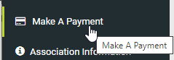

Make a payment online or sign up for ACH
You may submit your payments online using one of our payment partners. These are self-initiated, one time or recurring debits from your credit card or bank account. This is the fastest way to have a payment posted to your account.
The below payment methods are available to you:
- Auto-Draft – Monthly assessment will be taken from your account on or around the 5th of each month. If fees increase, the increase will automatically be taken from your account.
- One-Time e-Check – A free, one-time payment using your bank account and routing number.
- Recurring e-Check – A free, recurring payment option using your bank account and routing number. This payment can be scheduled for any day of the month and set to recur monthly or quarterly. Please note if fees increase, you will need to return to this page to manually update the amount of assessment.
- Credit Card – One time or recurring payment using your credit card. There is a credit card fee of 3.95% of each payment to use this service. We accept Visa, Discover or MasterCard.

Click here to make your payment.
Once you click the link, the following will populate:
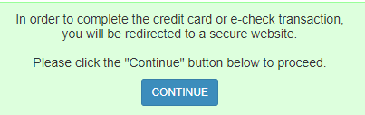
Click on Continue, the below will populate and you can make your selection, fill out the banking information or credit card info. Your payment is complete and you can rest easy.
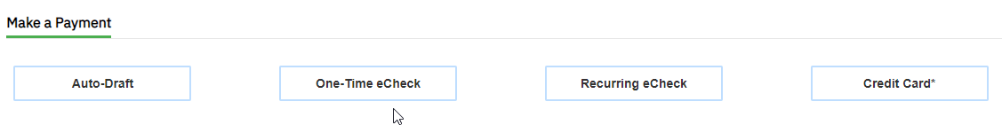

If you need any help setting up payments, please contact myself or the office at office@queenslanding.org who will be more than happy to get you started.

Jaci Hendricks
Treasurer
jaci@queenslanding.org

